English Worksheet 1

Have a look at these adverbial phrases.

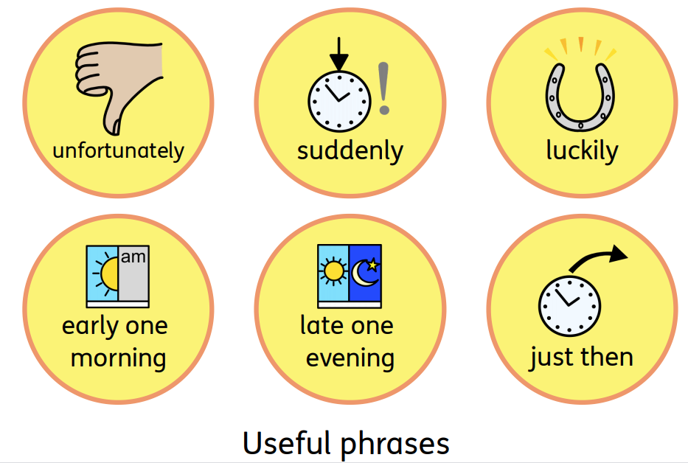

- See if you can add them into your story grid to make the story flow better. You might not need one in every box.

- Once you’ve added them in, practice retelling the story to yourself.

- When you are ready, find somebody to retell your story to out loud. It could be a brother, a sister, Mum, Dad, pet, or cuddly toy. Remember to use a loud voice so that they can hear you!

English Worksheet 2

Grammar

Colour in the verbs in the sentences below. Remember verbs are the doing words. For example, run, walk, talk, eat, jump are all verbs.

In the park, I like to hop. I like to play in the sandpit. Sometimes I get thirsty and I need to drink some water.

Main Activity

This week, we're going to have a go at changing the story of The Gigantic Turnip to make it your own.

You could change the vegetable in the story. Instead of the Gigantic Turnip, it could be The Gigantic Carrot! Have a think about what other vegetables you could have in your story and write down your ideas. It is a good idea to pick a vegetable that grows in the ground.
English Worksheet 4

- Finish drawing pictures in your story retell grid.
- Add in some adverbial phrases to the story grid.

- Think about what key words you will use in your story. Add these key words to the story grid.

English Worksheet 5

- Practice retelling your new story to yourself. Don’t forget to use your key words and adverbial phrases. If you have some craft materials at home, you could make puppets to help you retell the story. If not, don’t worry.

- When you are ready, find somebody to retell your story to out loud. It could be a brother, a sister, Mum, Dad, pet, or cuddly toy. Remember to use a loud voice so that they can hear your super story.

