English Work Sheet 1

Look at the front cover of this book.

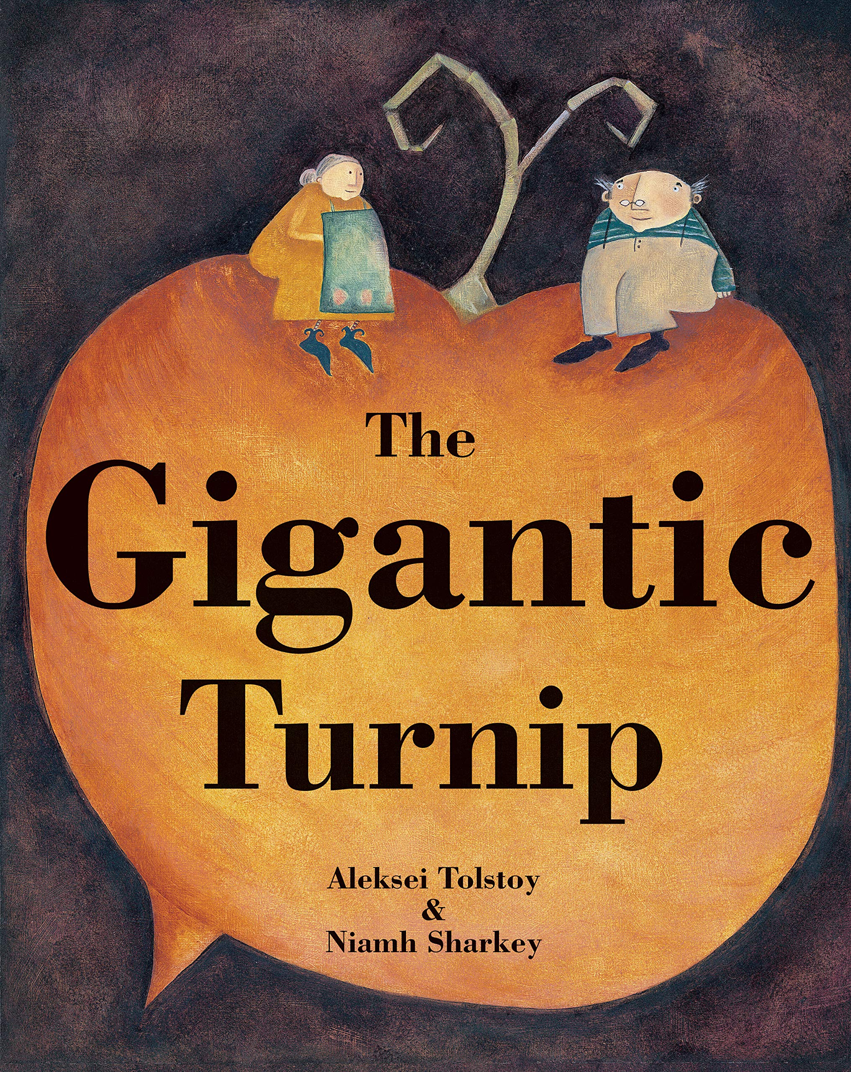

What do you think this story might be about?

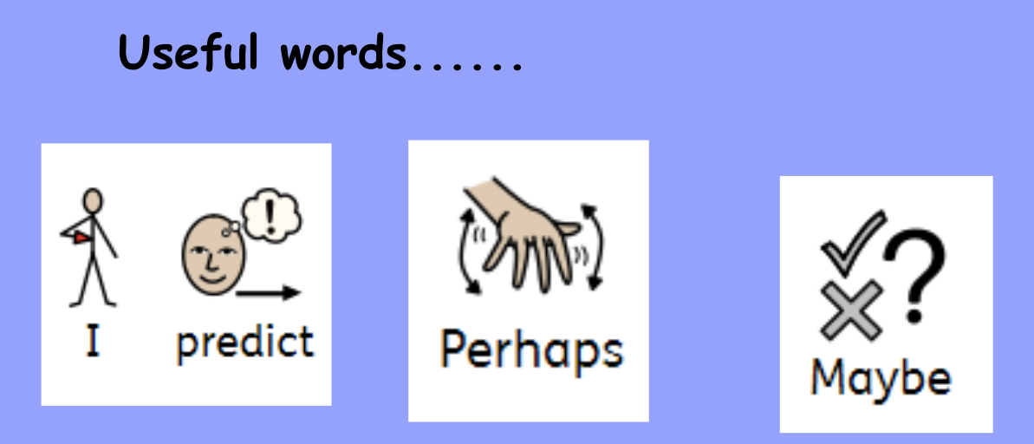

Now draw your prediction. Write a sentence about what you think, using a useful word. Don’t forget capital letters, full stops and finger spaces!

