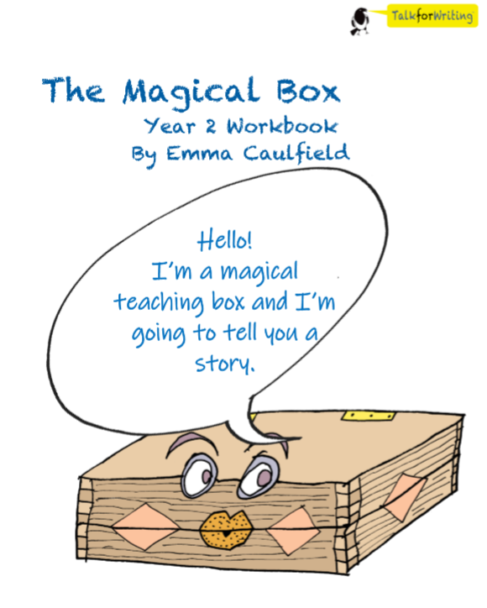

English. Monday 8th June 2020.
You will need to read the story again. The story is in your packs from last week. You can answer these questions on the next page.
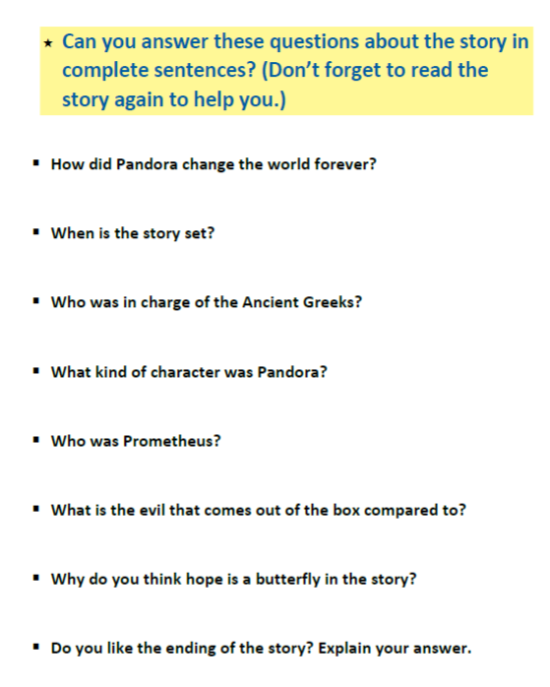

____________________________________________________________________________________________________________________________________________________________________________________________________________________________________________________________________________________________________________________________________________________________________________________________________________________________________________________________________________________________________________________________________________________________________________________________________________________________________________________________________________________________________________________________________________________________________________________________________________________________________________________________________________________________________________________________________________________________________________________________________________________________________________________________________________________________________________________________________________________________________________________________________________________________________________________________________________________________________________________________________________________________________________________________________________________________________________________________________________________________________________________________________________________________________________________________________________________________________________________________________________________________________________________________________________________________________________________________________________________________________________________________________________________________________________________________________________________________________________________________________________________________________________________________________________________________________________________________________________________________________________________________________________________
Tuesday 9th June 2020.
HINT: Look at the first letter of the word.
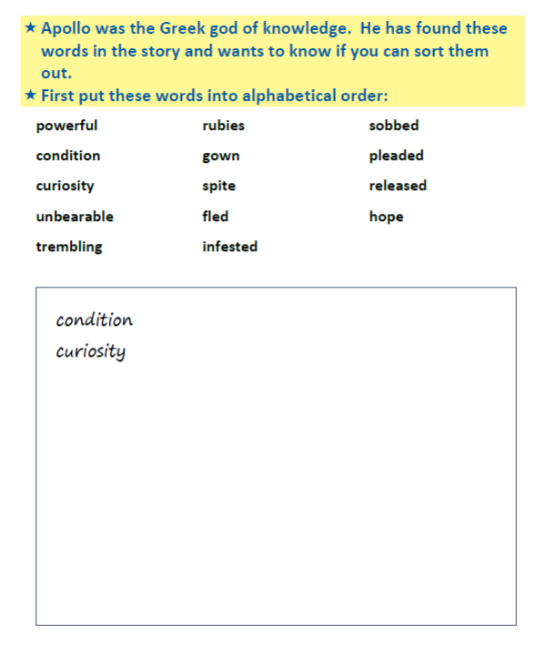

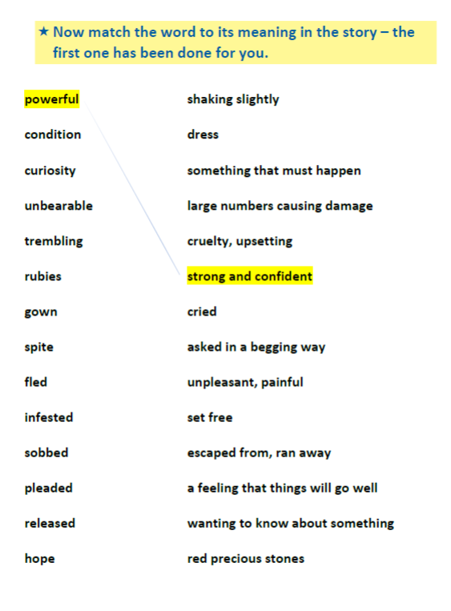
HINT: Use a dictionary. If you don’t have one, you can search the meaning of each word on google.

Wednesday 10th June 2020.
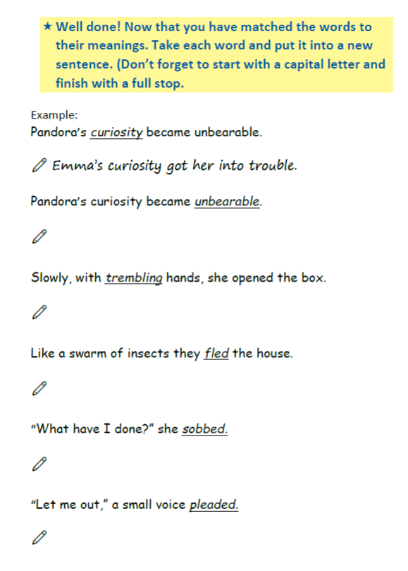
There is more space on the next page if you need more.
___________________________________________________________________________________________________________________________________________________________________________________________________________________________________________________________________________________________________________________________________________________________________________________________________________________________________________________________________________________________________________________________________________________________________________________________________________________________________________________________________________________________________________________________________________________________________________________________________________________________________________________________________________________________________________________________________________________________________________________________________________________________________________________________________________________________________________________________________________________________________________________________________________________________________________________________________________________________________________________________________________________________________________________________________________________________________________________________________________________________________________________________________________________________________________________________________________________________________________________________________________________________________________________________________________________________________________________________________________________________________________________________________________________________________________________________________________________________________________________________________________________________________________________________________________________________________________________________________________________________________________________________________________________

