English. Monday 4th May 2020.
Last week, we used our boxed-up grid to plan our own adventure story to a far away place.
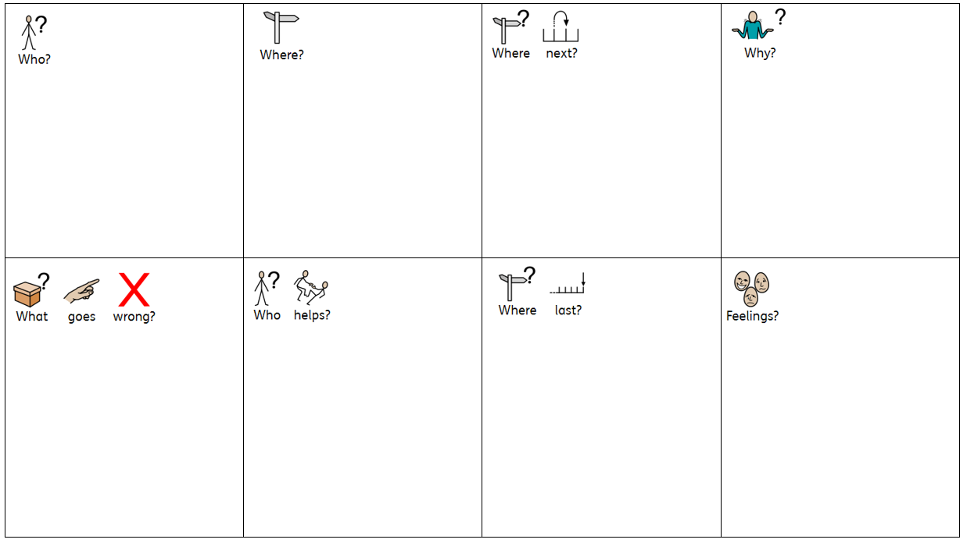

Retell your boxed-up story to another member of your family.

Then, on a piece of paper, begin to write your adventure story. Write about the first 4 boxes only.

English. Tuesday 5th May 2020.
Retell what you have written so far to another member of your family.
Does it make sense? Is there anything you’d like to change or improve? Use a different colour pencil or pen, if you have some, to make your improvements.

Then, on the same piece of paper, finish writing your adventure story. Write about the last 4 boxes.

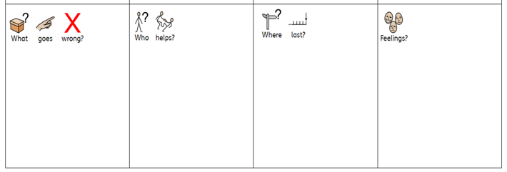

Wednesday 6th May 2020.
Re-read your work and then retell the story to another member of your family. Have a discussion about what you have written. What did your family member like most about your work? Is there anything they think you could improve?
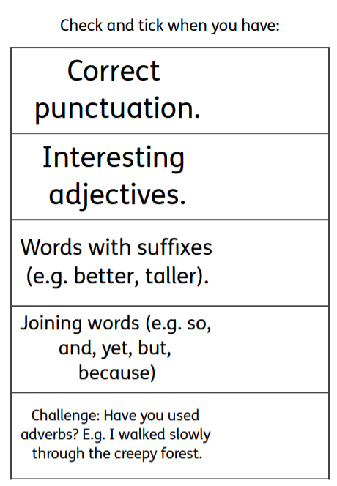
Look at the checklist below After checking, think: does it make sense? Is there anything you’d like to change or improve? Use a different colour pencil or pen, if you have some, to make your improvements.

