English. Monday 18th May 2020.

Look at your story from last week.
Write about your last 4 boxes.

After you finish, read your work. The re-read it to a member of your family.

Look at the checklist and edit your work using this checklist.
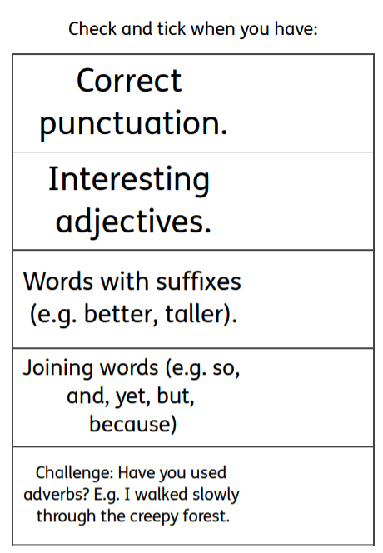

Tuesday 19th May 2020.
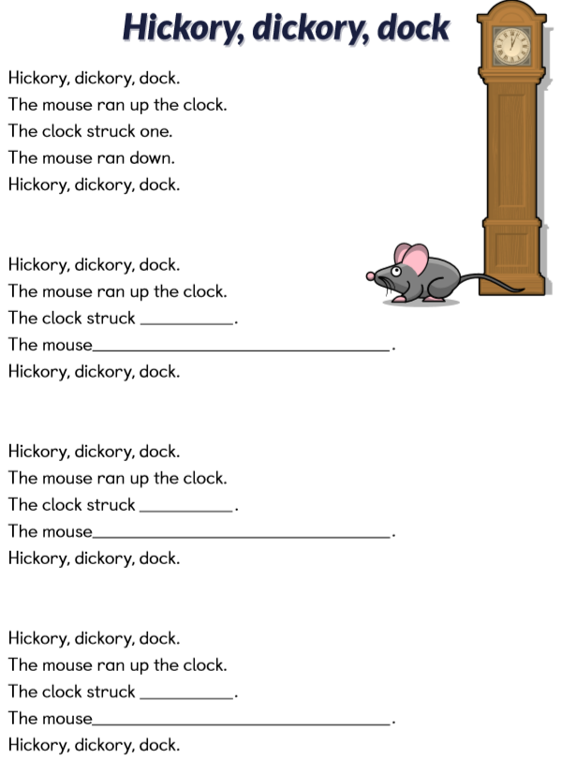
Here is a well-known poem called ‘Hickory, dickory, dock’. Read the first bit. Notice how the end words rhyme. In the poem there are a few blank spots for you to fill. For example: The clock struck two. The mouse ran into my shoe.
Now, how did you feel about that piece of poetry? Look at the sheet. Write down your response to each question. You can draw what you thought for some parts if you want to.
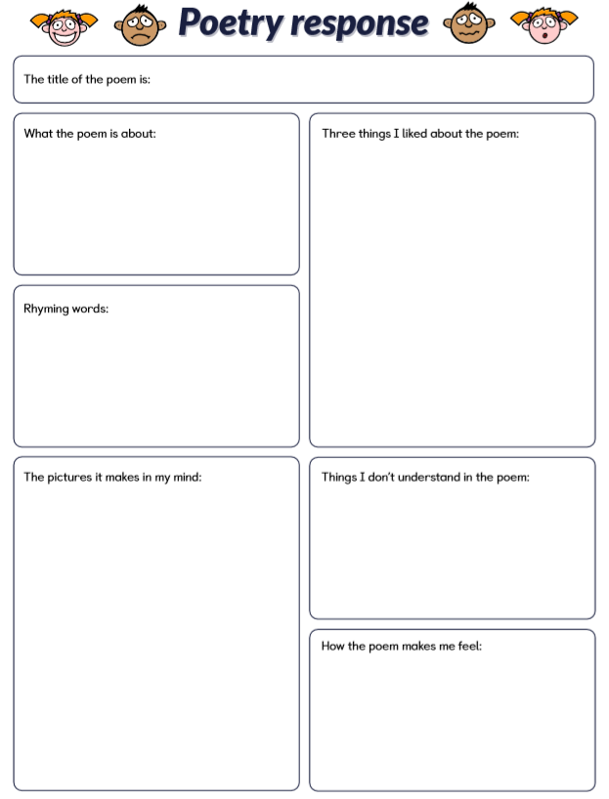

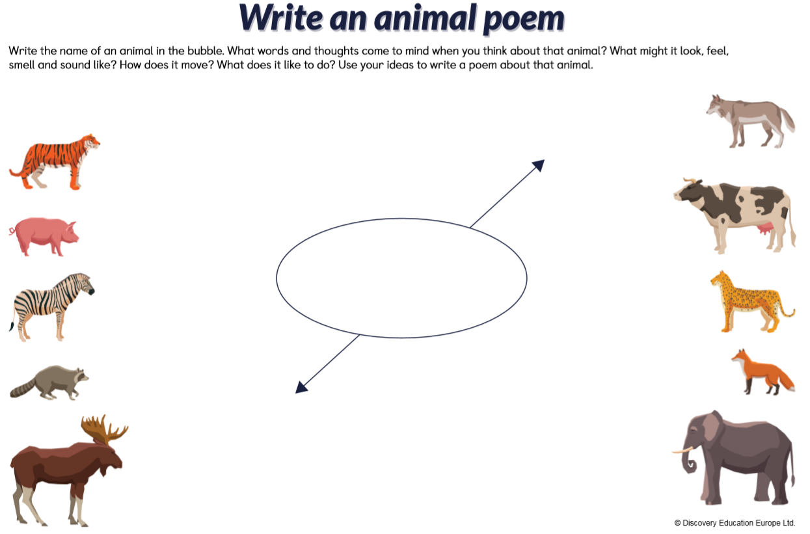
Wednesday 20th May 2020.

