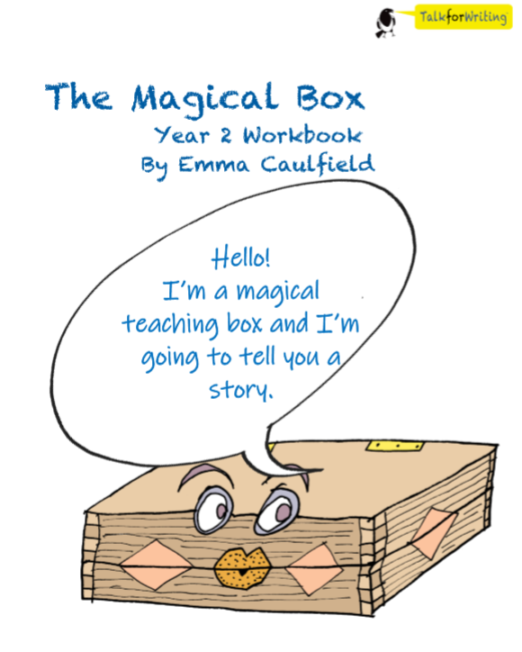

English. Monday 1st June 2020.
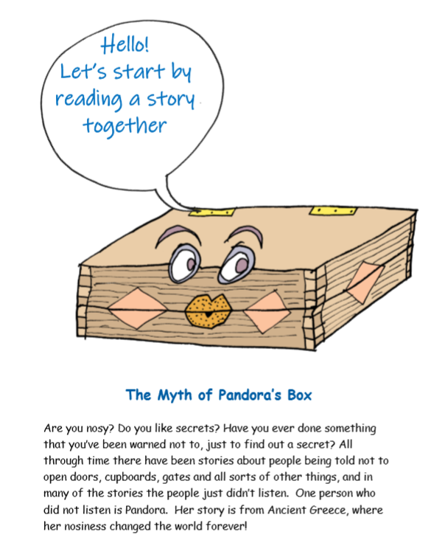
Read the first part of the story about ‘The Myth of Pandora’s Box’. What does myth mean? Maybe you could do a bit of research on this first.
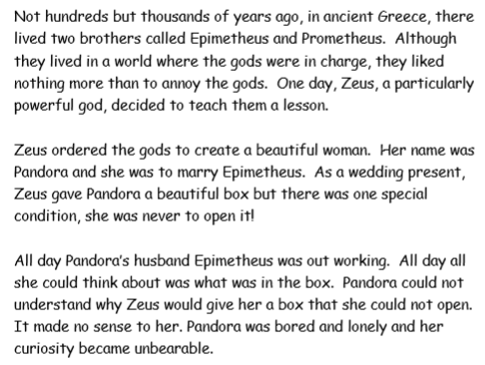
Activity time.
What do you think the box looked like? Re-read the story again, and see if you can see anything that might give you a clue to what it looked like.
Draw it here and don’t forget to label it!

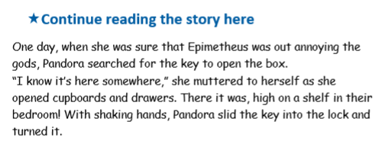
This time, have a think about what might be inside the box.
Draw or write about what might be in the box here:

Tuesday 2nd June 2020.
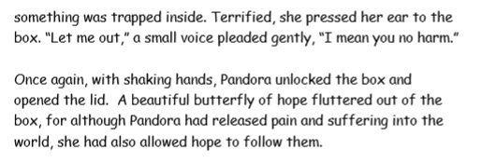
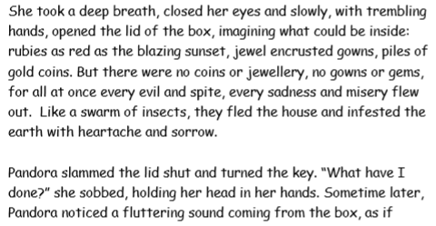
Read this section. You have an activity to do at the end.

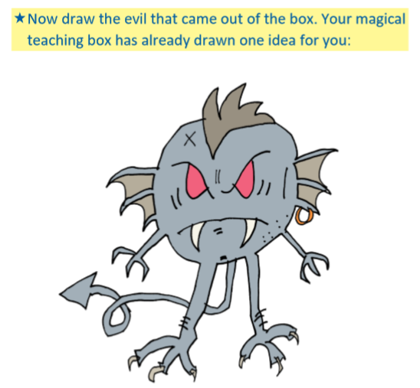
Spine-chilling
scary
terrifying

Challenge:
After you create your evil thing:
- Give it a terrifying name.
- Label your creature with 3 adjectives (oomph words). Have a look at the example above.
- Write a sentence to describe the evil thing.

You can draw it on the next blank page.

Page to draw your evil thing.

Wednesday 3rd June 2020.
Share the story with someone at home. Talk about what you liked and why you liked it so much. Then complete the ‘Tell me’ grid’.
