English Starters: Handwriting and spelling Week 2 (27th April)

Monday:
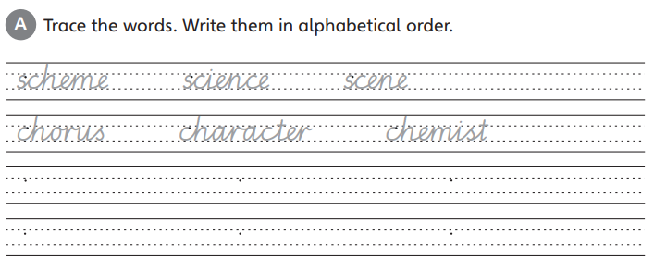

Tuesday:
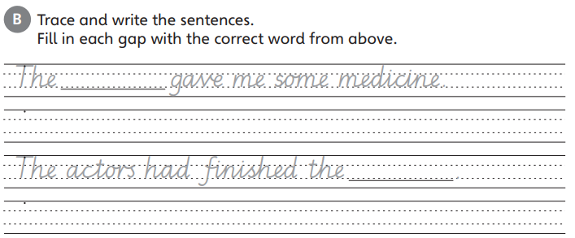

Wednesday: Homophones
List as many homophones as you can e.g.
see sea
night knight

Thursday: Prefixes
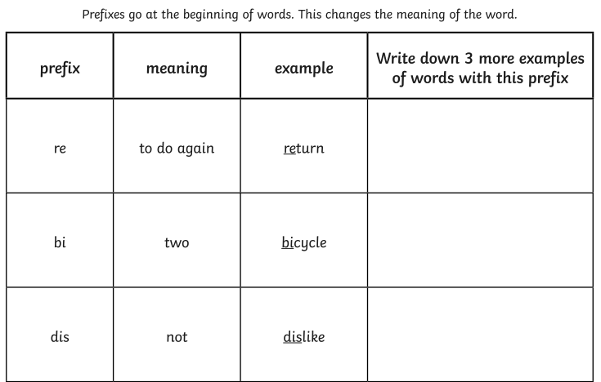

Friday- Prefixes continued
