English- WB 4th May
Monday-
Starter:
What is a diary entry? What does a diary entry include? Compete brainstorm.

Diary entry

Main task: Continue reading chapter 2 until Hogarth runs home and tells his family about seeing the Iron man.
‘His father frowned. His mother grew pale. His little sister began to cry. His father took down his double-barrelled gun. He believed his son. He went out. He locked the door. He got in his car. He drove to the next farm.’ Stop here.
Imagine you are Hogarth. You have just seen the Iron man, you have just told your family, you are about to go to bed and decide to write in your diary. What will you write? How are you feeling? What do you think will happen?
Dear Diary,

Tuesday-
Starter: Common Misspellings
Log into science bug, complete activity: ‘Common Misspellings’ under ‘My stuff’.

Main task:
Continue reading until you get to the part where the farmers have to decide what to do with the iron man.
‘They couldn’t call the police or the Army, because nobody would believe them about this Iron monster. They would have to do something for themselves.’

What do you think Hogarth’s father should do?
Write a letter giving him some advice.
Remember to use formal language and persuasive language techniques- - Rhetorical question Power adjectives - Long sentences for description - Short sentences for emphasis

Dear Farmer,

Wednesday-
Starter: Suffixes
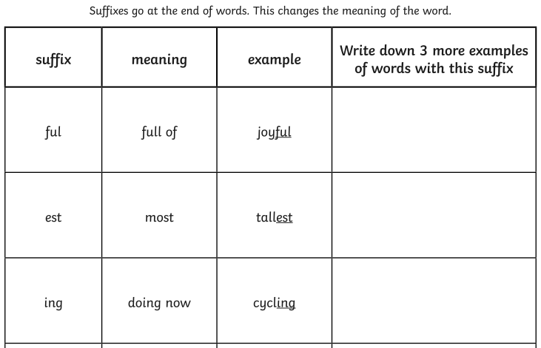

Main task:

Read till the end of chapter 2.
Answer the following questions:

- How do the author (Ted Hughes) use show not tell to show us the Iron man was angry when he was in the pit? What words did he use?

- What have the farmers done to the Iron man?

- Why does Hogarth feel guilty?

4. Find some examples of onomatopoeia used in chapter 2-
-
-
-
-

Thursday
Starter: suffixes continued
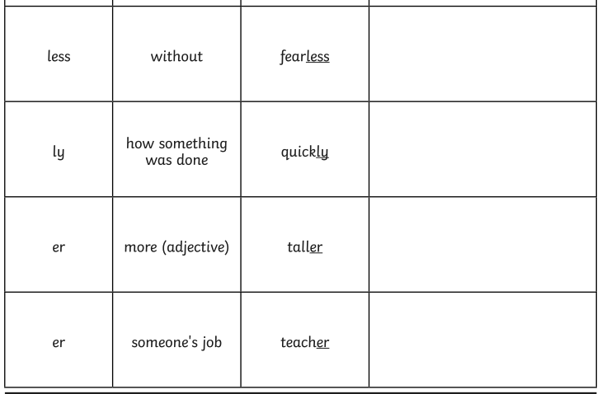
Main task:
Read chapter 3. Add to the tell me grid from the week before. 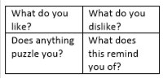
Use a different coloured pen if you can so we can see how your opinions and knowledge have changed and developed.

Friday-
(Friday work will not be linked to the Iron Man)
Task: Write a diary entry about how your week has gone. What have you been doing to keep busy? How are you feeling? Most of you have family who are fasting during Ramadan. How is it going?

Dear Diary,

