English/literacy (week beginning 27th April)
Romeo and Juliet (LESSON 3)

Monday 27th April

LI: Use a range of adverbials of manner to describe action

Task 1: Synonym Roll
You have 2 minutes to write down as many synonyms for the word 'jump' as you can find/think of.
https://www.wordhippo.com/whatis/another-word-for/jump. html
Task 2:
Re-read p.8-9 of your Romeo and Juliet photocopied book.
If you haven't got enough people in your family to act it out, watch this clip of the scene from the 1968 film version Of Romeo and Juliet.
https://www.youtube.com/watch?rel oad=9&v=xawp9c017Z4
As you watch the scene, note down all the relevant verbs that you can see in your exercise book e.g. slash, shout, race, lunge.
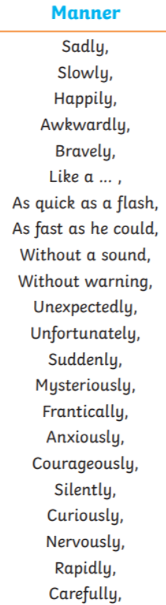

Task 3:
Can you improve this sentence?
How did Benvolio jump at Benvolio? (use a fronted adverbial of manner-see opposite or make up your own)
Can you choose an alternative synonym for 'jump

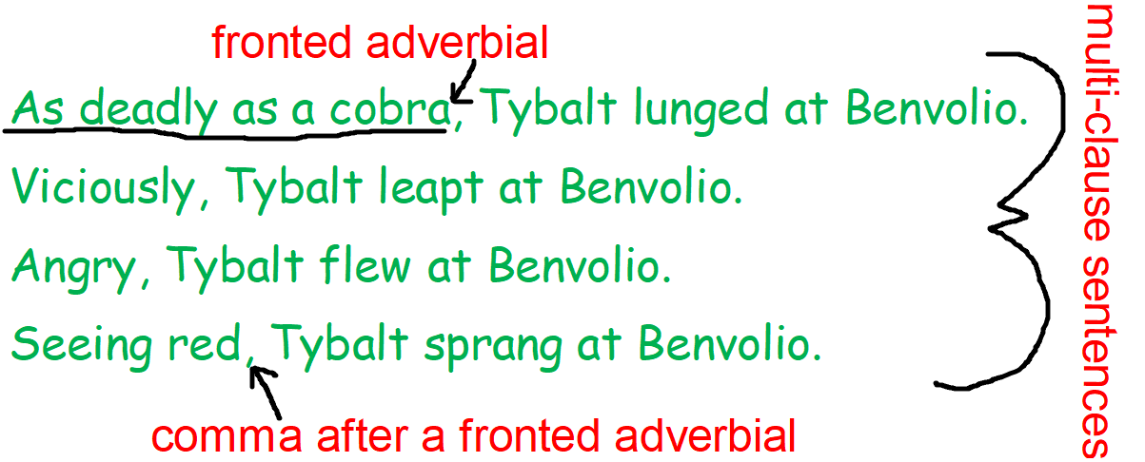
Tuesday 28th April
Look back at yesterday’s work. Remember the first fight scene?
Task 1:
Today you need to write a short paragraph describing that first fight scene, including:
- multi-clause sentences with adverbials of manner
- fronted adverbial (at beginning of sentence)
- comma after fronted adverbial

Example:
Many years ago, the two chief families in Verona were the rich Capulets and the Montagues. There had been an old quarrel between these families, which was so deep and so deadly that even the servants would fight each other when they met on the street.
One misty morning, two Capulet servants, Gregory and Sampson started yet another brawl. Sampson bit his thumb as a Montague servant walked by. Insulted by this gesture, the Montague servant told him to draw his sword. Soon, other people joined in. Benvolio, a Montague didn't like the fighting. As calmly as he could, he tried to stop it. Unfortunately, Tybalt, a Capulet, wouldn't listen. Angry, he lunged at Benvolio, brandishing his sword fiercely.
Challenge: Start by writing an informal description of the scene then include the Prince's Royal Proclamation which would be a more formal, regal tone.

Wednesday 29th April
What do we know about the character of Tybalt?

Here is his first speech:
What, drawn, and talk of peace! I hate the word, As I hate hell, all Montagues and thee.

What does this tell us about him?
- Capulet (Lady Capulet's nephew)?
- A swordsman?
- Fiery temper?
- Strong sense of hatred towards the Montagues?
- A trouble-maker?
Task 1:
Add these phrases to your Tybalt doll on your character map from last week.

Task 2:
In your exercise books: What do you think will happen to Tybalt later in the play/ story? What are your predictions for his future or the future for both families?
Remember to include modal verbs and conjunctions:
I think/predict that...because...
Perhaps...because/ since/ as/ due to...
should...
Before...he ought to...

Maybe...
Although...it could be that... . will...

ROMEO and JULIET (LESSON 4)

Thursday 30th April

LI: Use dialogue for characterisation

Task 1:
"70% of communication is body language."
depressed | tired | frustrated | angry
annoyed | excited | happy | distracted
bored | moody | confused | confident
shy
What do you think of this statement? Do you think it's true?

How many ways can you say "I'm Fine"? Choose one of the emotions above, say "I'm fine" in that emotion and ask someone in your family to guess which emotion you chose.
Task 2: Read p.10 — 11 of your Romeo and Juliet book. Act it out with some willing members of your family! Now think about Romeo's body language — forlorn, dejected and lovesick.

"Not I, my heavy heart will weigh me down," Romeo said whilst....
What are the things that Romeo might be doing whilst talking? Can you think of some synonyms (alternatives) for said? Complete the sentence above in your exercise book. e.g. "Not I, my heavy heart will weigh me down," Romeo sighed whilst slumping down against the wall and staring up at the distant stars.
Task 3: Write a piece of dialogue (talking) between Mercutio, Romeo and Benvolio. Focus on the dejected (gloomy) body language of Romeo and contrast this with the more upbeat(cheerful) body language of Benvolio.
Challenge: Write it as if it had happened in 2020. Maybe you could include the characters receiving a very formal Royal party invitation in the post that they read out.

"Hi cousin", cried Benvolio, cheerfully. "What's wrong?"
Romeo slumped down against the wall.
"I really like someone but they’re just not that bothered," he began, his head in his hands.

Friday 1st May: (PSHE/literacy)
RED HAT
If you have access to the internet look at the PSHE collection on the ‘Once upon a Picture’ website to see a clearer picture of Red Hat opposite in colour.
https://www.onceuponapicture.co.uk/the-collections/the-pshe-collection/
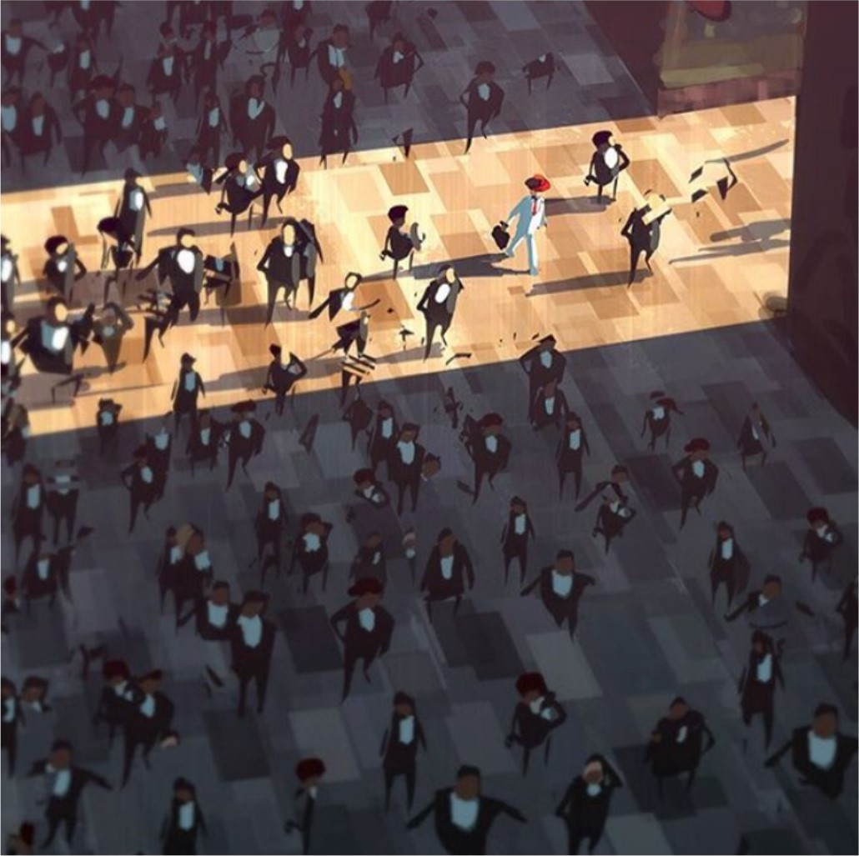

- Where is this?
- Where is the light coming from?
- Who are all of the people?
- Why is the man in the red hat dressed differently to everyone else?
- How do you think the others feel towards him? How does he feel towards the others?
- Do you think he feels proud to be different? Or could he feel ashamed?
- Have you ever done something that you stand out? How did it feel?
- Do you think people should try to fit in? When is it good to be different? When is it bad?
- Research historical figures that are known for being different, or for standing up for change.
- Compare this image with the image ‘Different’ from last week. What's similar and what's different?

