English- WB 27th April
Monday- Making predictions
Task 1: Make predictions about character based on image
What do you see?
What kind of character do you think he will be?
What do you think will happen to him in the story?
Write some keyword around the image
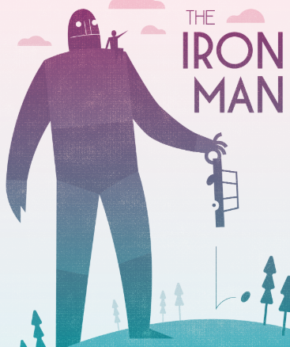
Write your predictions using some of the sentence starters-
Based on the image, I predict..
Based on what the character is doing I predict.. I think this because…
Perhaps…
Although..

Task 2: Read the blurb
Make another prediction, what do you think will happen in the story?

Tuesday: Booktalk and discussions

Read chapter 1.
Reread chapter 1 and answer these questions as you read

(p13) What’s the effect of the repetition of “Nobody knows” in the 2nd paragraph?
(p13) “The wind sang through his iron fingers” – what language technique is this?

(p13) Why did he jump off the cliff? Where has he come from?

(p14) What is the effect of the short sentence: “Then Silence.”?

(p14) Why is the text laid out on separate lines when it is describing the Iron Man’s fall?

(p14) Why has the author compared the Iron Man’s fingers to a crab?

(p15) What do you think the seagull has picked up?
(p16) What is the hand searching for?
(p17) How long did it take to piece himself back together?
(p18) “He walked into the breakers” – what are “the breakers”?
(p18) Why do you think the eyes turned green?

What kind of story do you think it might be?

What do you think will happen next?

Wednesday- Opinions of text
Fill out grid: What do you like so far? What puzzles you? What do you dislike? What type of story is this and how do we know? Does this opening remind you of another story? What are the similarities between this and others you already know?
What do you like? | What do you dislike?
Does anything puzzle you? | What does it remind you of?

Thursday: Character description
Using the information given to you in chapter 1, write a character description of the Iron Man.
What does he look like?
Use the 5 senses, look like, smell like, sound like, feel like
Use your own similes, metaphors, personification
Use your own powerful vocabulary

Friday: Visualising the scene
Read the first 2 pages of chapter 2. Stop at ‘There was another clue.’

We’re introduced to Hogarth who saw the iron man for the first time.
Close your eyes and visualise the scene by the stream.
Imagine you are Hogarth, think about what you can see and how you feel.
Draw the scene below, annotate (label) the picture with powerful noun phrases describing how you feel and what it looks like.

