English- WB June 1st : News Report
You are completing Week 3 lessons from Oak National Academy- News report (Website: Type in Oak National Academy). Most activities can be completed in your English books, I have copied some tables from some lessons to make it easier for you.
Monday 1st June-
Complete activities- answer the comprehension questions based on Charlie and the chocolate factory. Practice spellings in English exercise books.
Tuesday 2nd June -
Answer the inference questions based on Charlie and the Chocolate factory in your English book and practice spelling.
Wednesday 3rd June-
Answer the questions based on features of a newspaper report in your books. Practice spelling words.
Thursday- SPAG Inverted commas
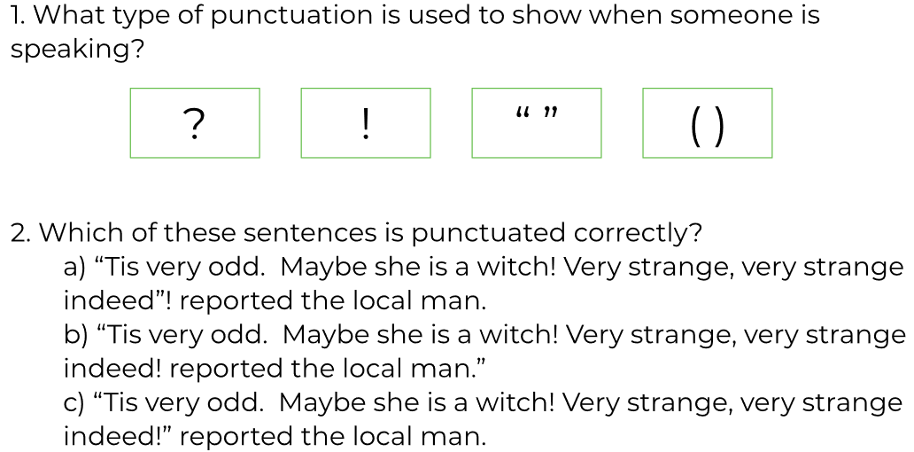

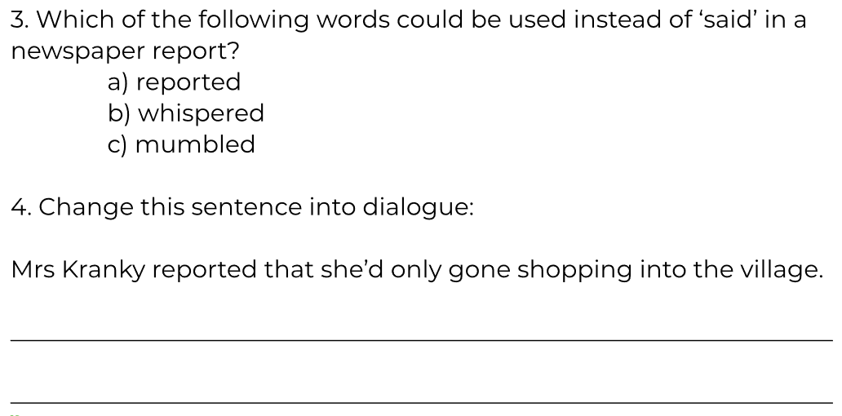
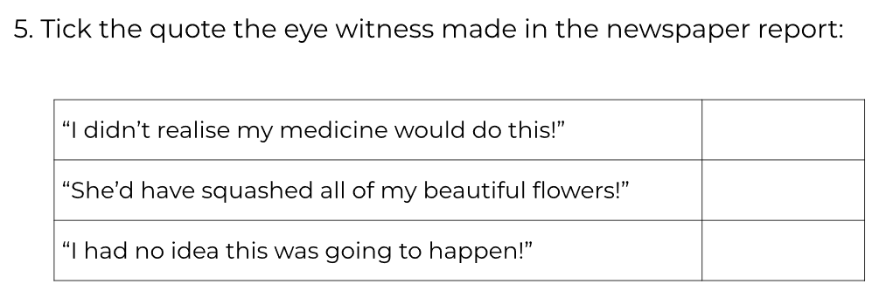
Practice the spellings in your books.
Friday 5th June-
Follow the instructions to write the news report in your English books.

