English - WB 8th June – Writing a Diary Entry
Before you start the activities, you will need to complete the quiz and watch the video. Some activities you can complete in your new English books but some tables I have copied for you so you do not need to draw the table. You can cut and stick them in your book with the rest of the work from that day.

Monday-Diary Entry: Reading Comprehension -Inference
Complete the questions 1,2,3,4, 5, 6 and 7 in your book.
Complete the final spelling challenge in your book.

Tuesday -Diary Entry: Reading Comprehension -Fact Retrieval
Complete the questions 1,2,3,4, and 5 in your book.
Number 6 is below

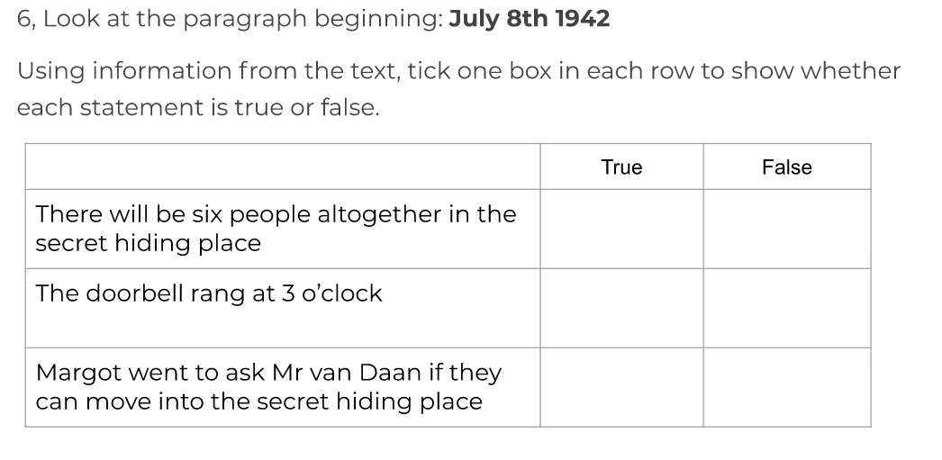
Complete the final spelling challenge in your book.
.

Wednesday- Diary Entry: Identifying the features of a text
Complete the independent task on slides 6 and 7 in to your book.
Below is a list of features you will need to identify as you read the extract.
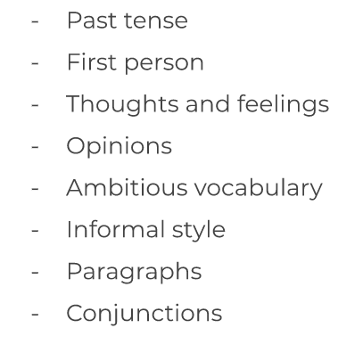

Complete the final spelling challenge in your book.

Thursday- Diary Entry: SPaG focus – Formality
Complete the questions 1 to 5 on the slides and then have a go at practicing your spellings.

Friday- Diary Entry: Write a diary entry
Write your own diary entry in your exercise book. Follow the slides carefully using the instructions and key words/phrases to support you.

