English - WB 22nd June – Writing a Diary Entry
Before you start the activities, you will need to complete the quiz and watch the video. Some activities you can complete in your new English books but some tables I have copied for you so you do not need to draw the table. You can cut and stick them in your book with the rest of the work from that day.

Monday- Story: Reading Comprehension - To make comparisons within and across books
Complete the questions 1 to 3 in your book.
Complete the final spelling challenge in your book.

Tuesday - Story: Reading Comprehension - Predictions
Complete the questions 1 to 5 in your book.
Complete the final spelling challenge in your book.

Wednesday- Story: Identifying the features of a text
Complete the independent task on the slides by completing the filling in the boxes on the below table.
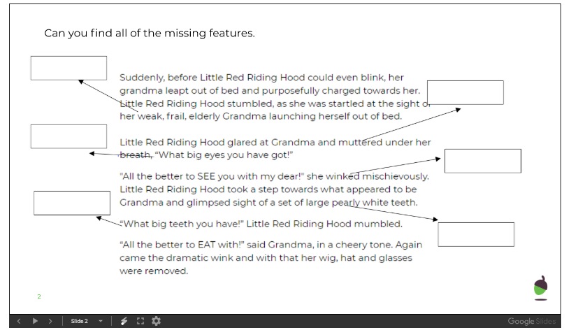

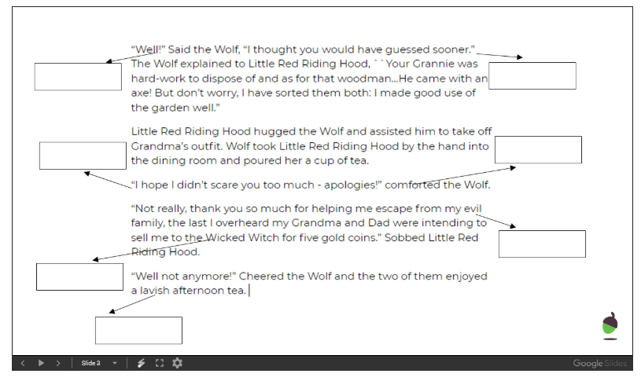

Complete the final spelling challenge in your book.

Thursday- Story: SPaG focus - Speech
Complete the independent task on the slides and then have a go at practicing your spellings.

Friday- Story: write an alternative ending to a story
Write your own alternative ending to a story in your exercise book. Follow the slides carefully using the instructions and key words/phrases to support you.

