English- WB 18th May: Poetry
Before you start the activities, you will need to complete the quiz (However there isn’t a quiz on Monday) and watch the video. Some activities you can complete in your new English books but some tables I have copied for you so you do not need to draw the table. You can cut and stick them in your book with the rest of the work from that day.

Monday-
Character Description: Reading Comprehension – Fact Retrieval
Complete the questions 1,2,3,4 and 5 in your book.
Complete the final spelling challenge in your book.
Below is the table for question 6. But if you feel ambitious have a go at drawing the table in your book if not you can complete on here.
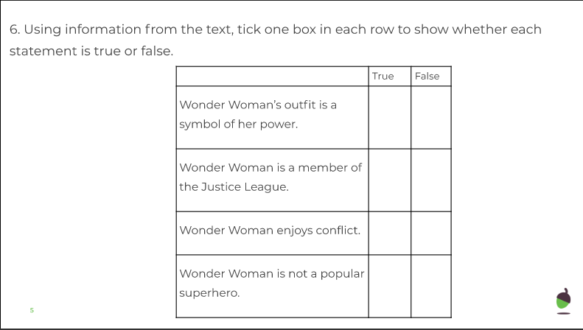

Tuesday
Character Description: Reading Comprehension – Word Meaning
Complete the questions 1 to 6 in your book.

Wednesday-Character Description:
Identifying the features of a text
- Below are the extracts for today’s lesson. Once you have finished please practice spellings and complete other activities in your exercise book.
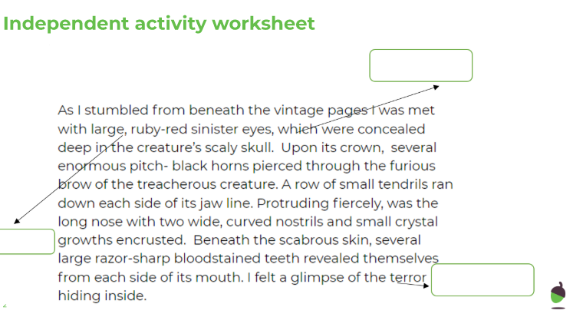
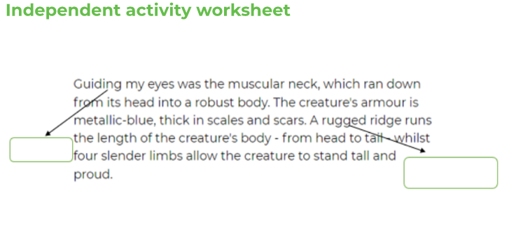
Wednesday-Character Description – continued…
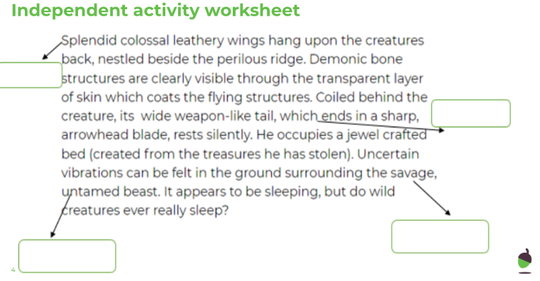

Thursday-
Character Description: SPaG focus – Relative Clause
Practice spellings and complete other activities in exercise books.

Friday-
Write your own setting description in your exercise book.

