English - WB 15th June – Writing a set of Instructions
Before you start the activities, you will need to complete the quiz and watch the video. Some activities you can complete in your new English books but some tables I have copied for you so you do not need to draw the table. You can cut and stick them in your book with the rest of the work from that day.

Monday- Set of Instructions: Reading Comprehension – Language
- Complete the questions and answers in your exercise book and then practice your spellings.
.
Tuesday - Set of Instructions: Reading Comprehension - Word Meaning
- Complete the questions and answers in your exercise book and then practice your spellings.
.
Wednesday- Set of Instructions: Identifying the features of a text
- The independent task has been copied for you below. Once you have completed this practice your spellings in your exercise book.
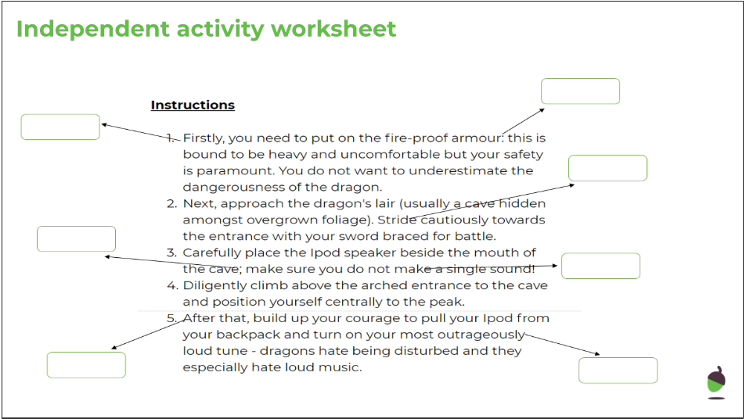

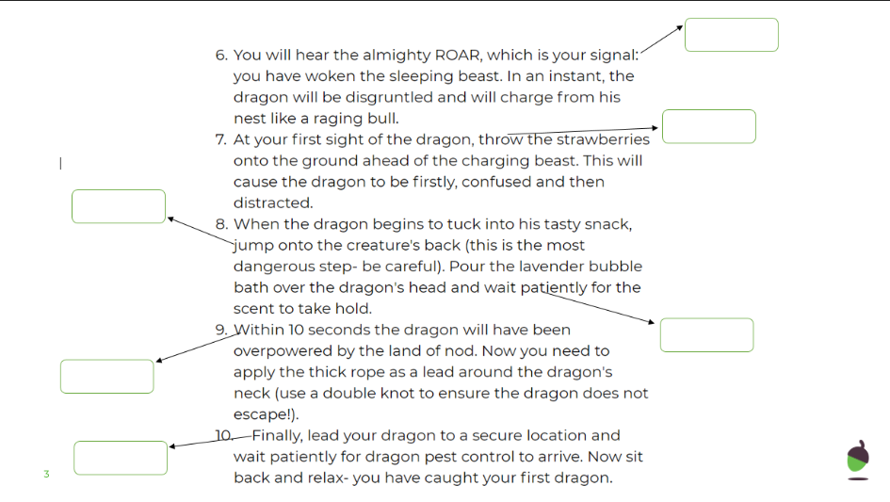

Thursday- Set of Instructions: SPaG focus - Cohesive Devices
- Complete the questions and answers in your exercise book and then practice your spellings.

Friday- Set of Instructions: Write a set of instructions
- Write your own set of instructions using the suggested language and structure provided.

