English - WB 1st June - Writing a Persuasive Letter
Before you start the activities, you will need to complete the quiz and watch the video. Some activities you can complete in your new English books but some tables I have copied for you so you do not need to draw the table. You can cut and stick them in your book with the rest of the work from that day.

Monday- Persuasive Letter: Reading Comprehension – Inference
Complete the questions 1,2,3,4, 5 and 6 in your book.
Complete the final spelling challenge in your book.

Tuesday - Persuasive Letter: Reading Comprehension – Word Meaning
Complete the questions 1,2,3,4, and 5 in your book.
Complete the final spelling challenge in your book.
.
Wednesday- Persuasive Letter: Identifying the features of a text
Below are the extracts for today’s lesson. Once you have finished please practice spellings and complete other activities in your exercise book.
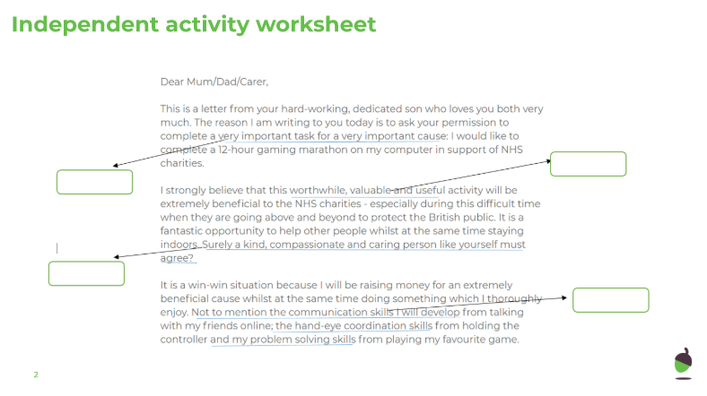
Wednesday continued…
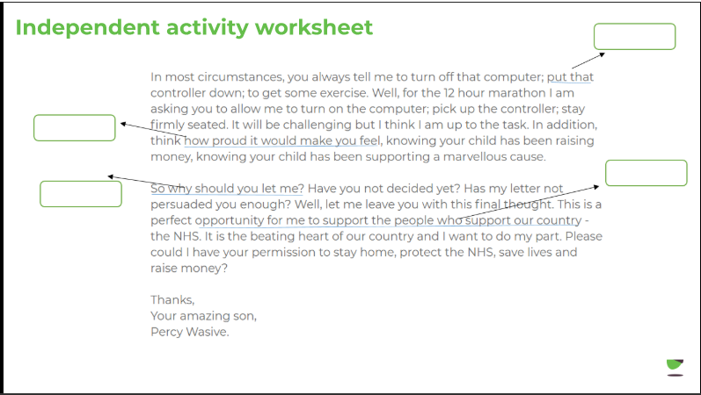

Thursday- Persuasive Letter: SPaG focus – List of three
Below are the activities for today’s lesson. Once you have finished please practice spellings and complete other activities in your exercise book.
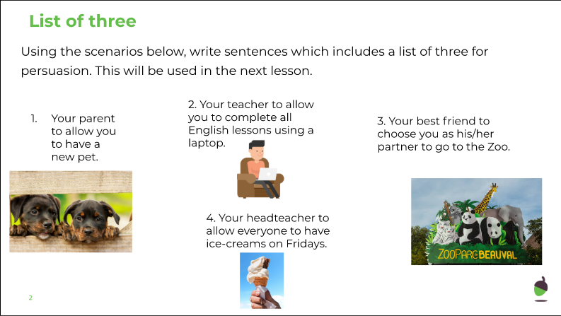

Thursday Continued…
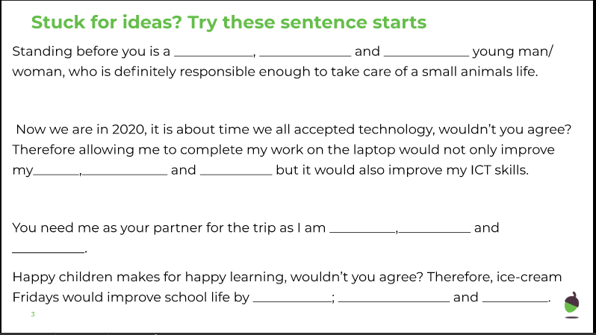

Friday- Persuasive Letter: Write a persuasive letter
Write your own persuasive letter in your exercise book. follow the slides carefully using the instructions and key words to support you.

