English- WB 11th May: Poetry
Before you start the activities, you will need to complete the quiz and watch the video. Some activities you can complete in your new English books but some tables I have copied for you so you do not need to draw the table. You can cut and stick them in your book with the rest of the work from that day.
Monday-
Complete activities and practice spellings in new English exercise books.
Tuesday-
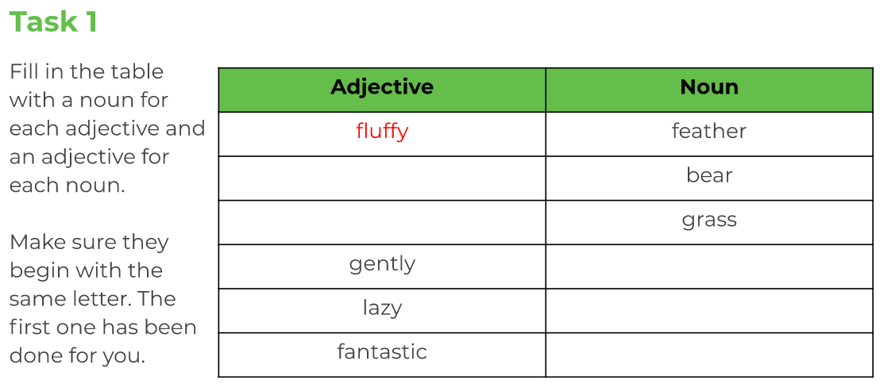
Practice spellings and complete other activities in exercise books.
Wednesday-
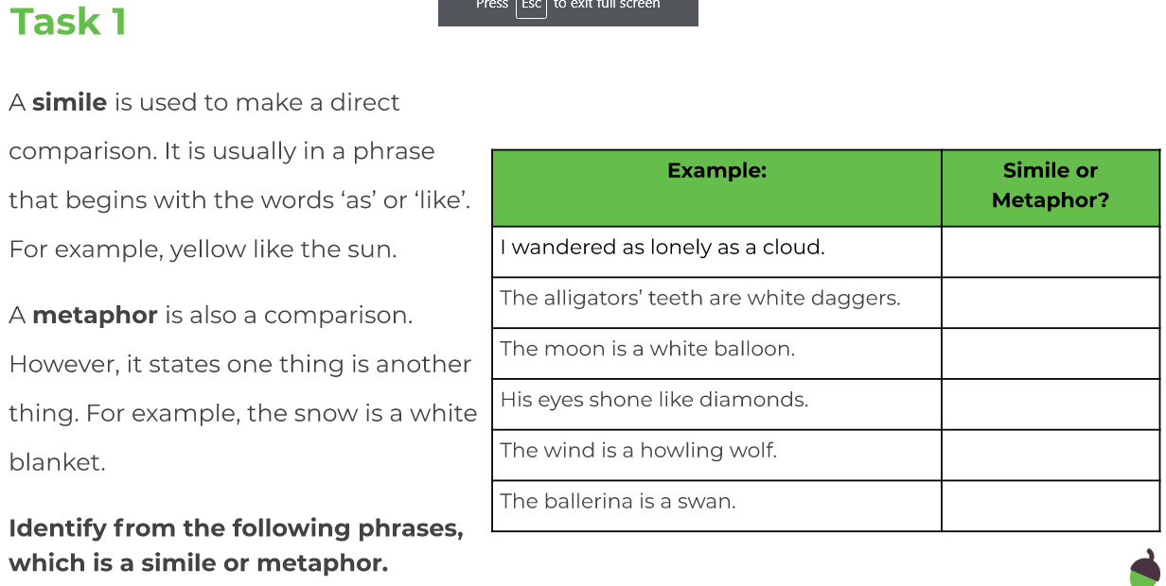
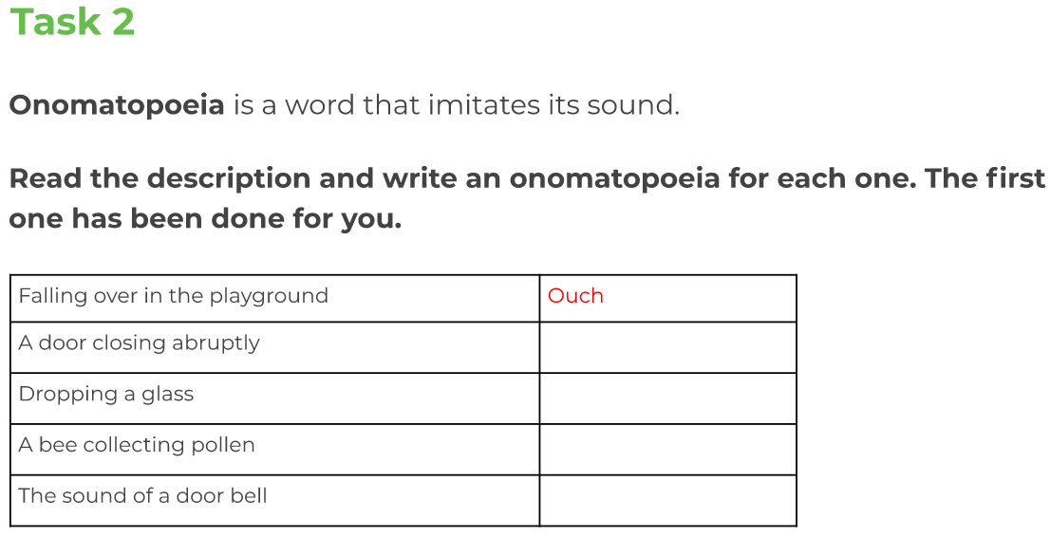
Practice spellings and complete other activities in exercise books.
Thursday-
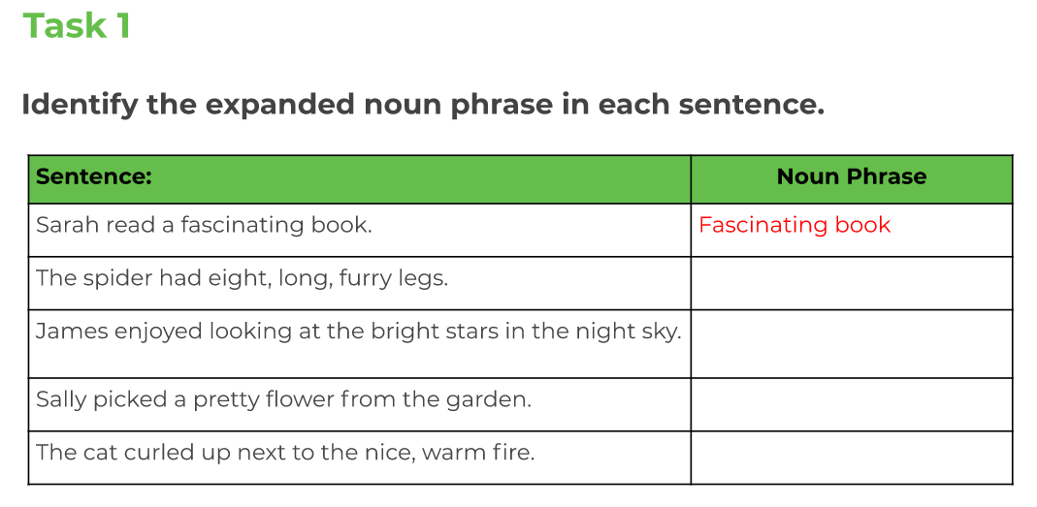
Practice spellings and complete other activities in exercise books.
Friday-
Write your own poem in your books.

