Deciduous Trees
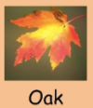
- In the Autumn, the leaves on some types of trees change colour and fall to the ground. These are called deciduous trees.
- These trees tend to have flat and wide leaves.
- Oak trees are deciduous.
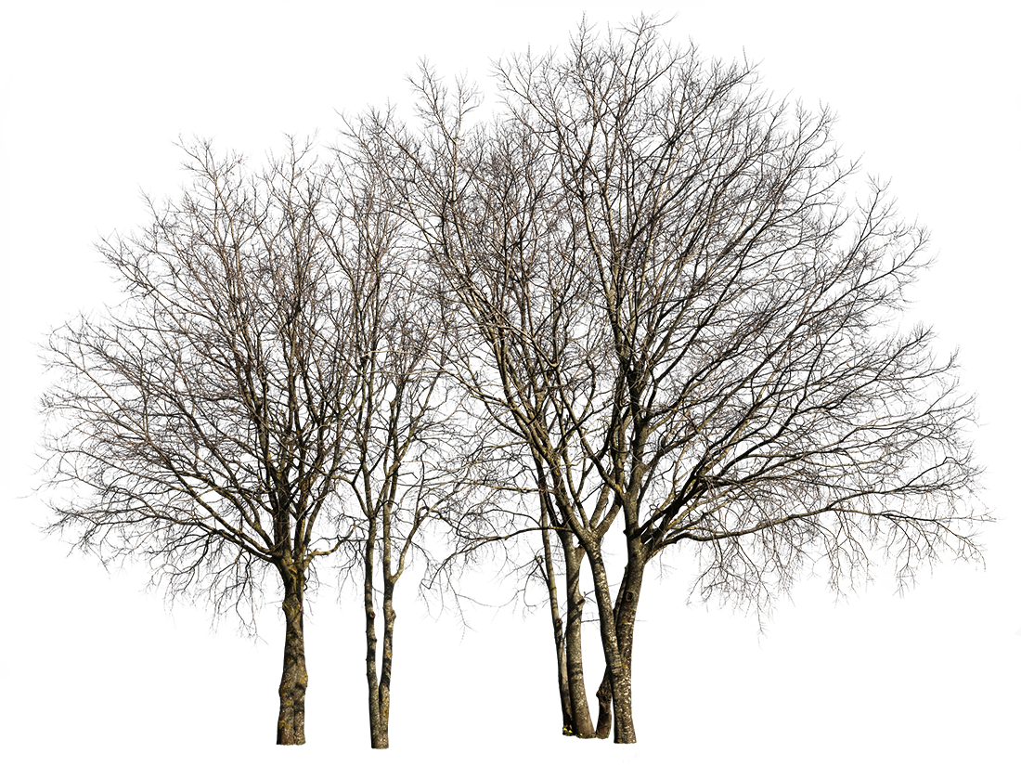

This is what a deciduous tree looks like in the winter, once it has lost its leaves.

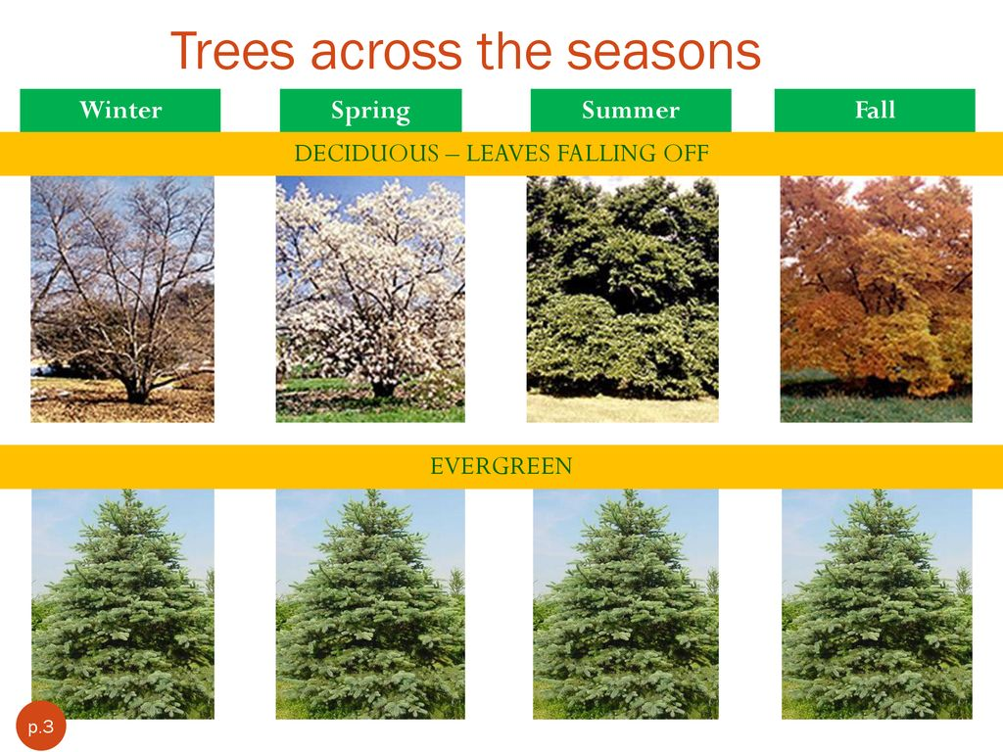
Autumn

Evergreen Trees

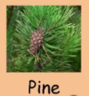
- Some trees do not lose their leaves. They have leaves all year round. They are called evergreen trees.
- These trees tend to have more thin and pointy leaves.
- Pine trees are evergreen.

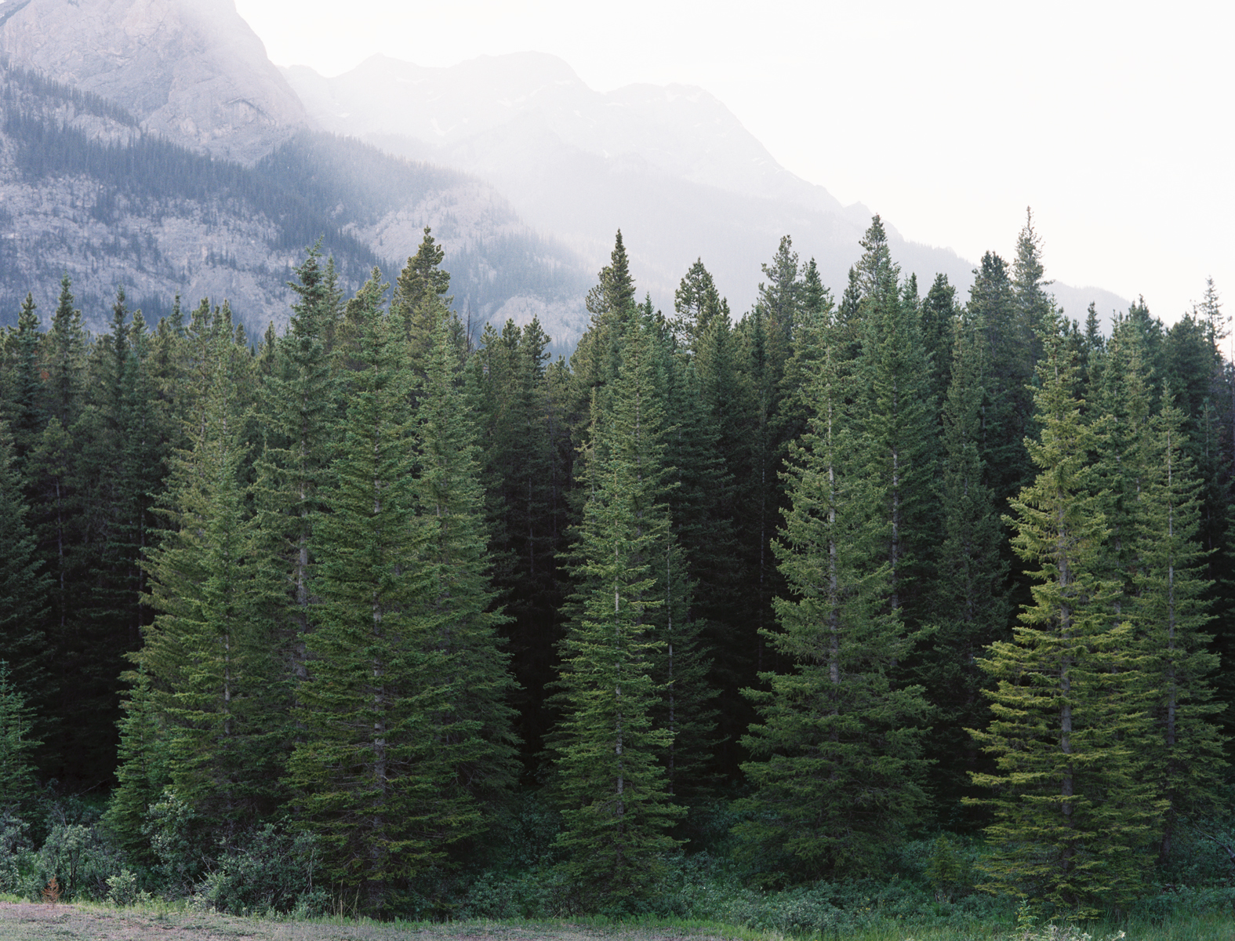
These evergreen trees, staying looking green all year round because they do not lose their leaves.

Science Worksheet

This is Ben. Ben has never heard of a deciduous tree or an evergreen tree before. He doesn’t know what they are. Can you help Ben to understand?
