Creative project WB 8.6.20
Tuesday 9th June 2020: Science
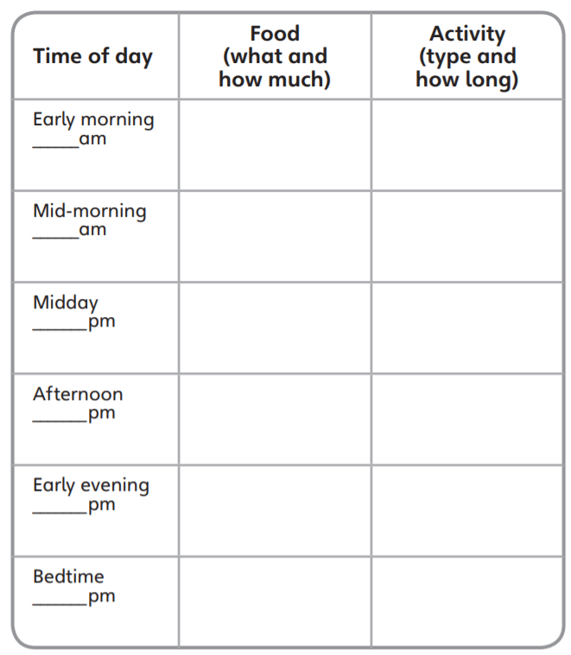
Use this plan to create a healthy lifestyle plan.
Wednesday 10th June 2020: Geography and science
Read the information. Ignore the big ‘science bug’ writing! You should still be able to read the information.
