Creative project WB 1.6.20
Monday 1st June 2020: Science
Look at your timetable to see what you need to do.
This is what I made the other day for lunch at home. My dish has pasta (carbohydrates), beef (protein), tomatoes and rocket (vegetables) and parmesan cheese (diary). Do you think my lunch was healthy? Why or why not? Have a go at making dinner with your family, thinking about what food groups you can see.

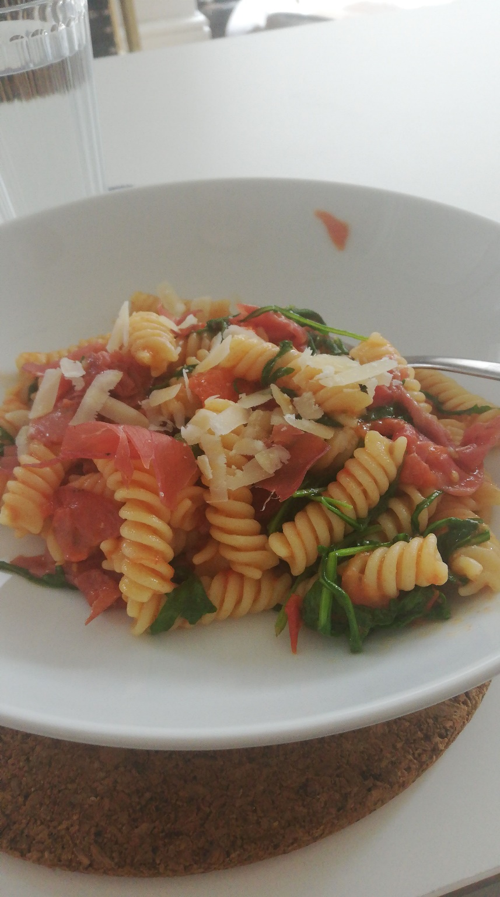

Tuesday 2nd June 2020: Science
Draw your healthy meal here and label it. Remember your different food groups.
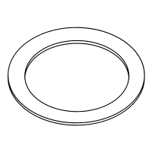

I know my meal is healthy because…

____________________________________________________________________________________________________________________________________________________________

Wednesday 3rd June 2020.
Map of my bedroom

Thursday 4th June 2020. ‘Thank you, NHS,’ example posters.
