ART and DT Monday 1st June 2020: Salt dough pottery
Stone Age people made bowls out of clay to use for cooking and for storing food and drink. You could try making a salt dough pot.

Ask an adult to help you make some salt dough.
You will need 1 cupful of flour, half a cupful of table salt, half a cupful of water.

Next ask an adult to help you make a salt dough mixture by mixing together the flour, salt and water (do not eat the dough, it is too salty).

Then you can roll out the salt dough into long sausages and coil them around in a pot shape like this:
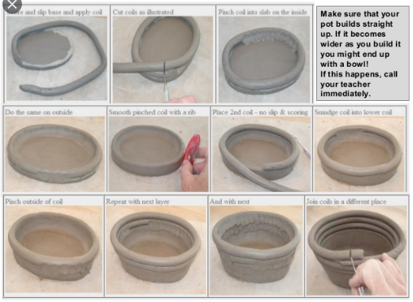

Or use your salt dough to make some model people, like these:

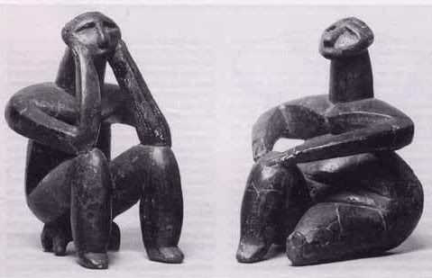
ART and DT Tuesday 2nd June 2020: Natural dyes
Think about how Stone Age people created dyes to colour the wool fabric that they made for clothes and rugs. Use the idea of natural dyes to make some dyes of your own.
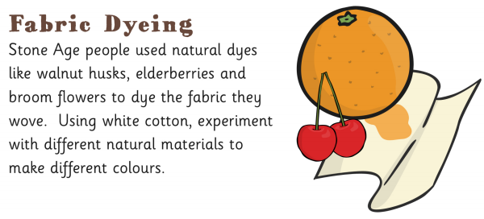
Try using some different brightly coloured fruits or vegetables like red onion, beetroot, oranges or cherries mashed up and mixed with water to create a coloured dye. If you are cutting up fruit, remember to ask an adult to help you. Use white or another light coloured fabric, dip it in your dye mixture then hang it up to dry.

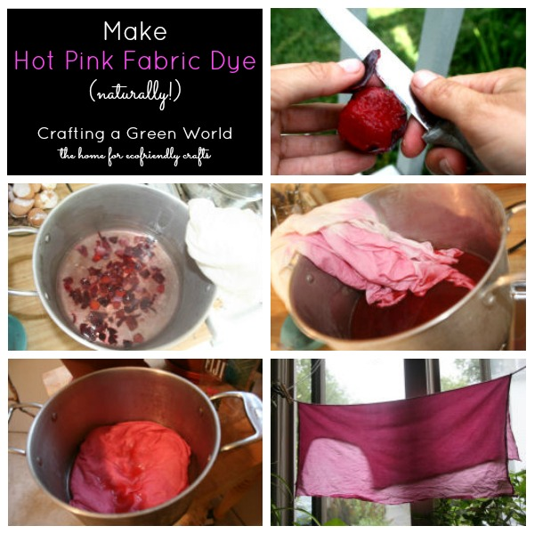
ART and DT Wednesday 3rd June 2020: Natural prints
Stone Age people created art and craft using the natural materials around them. Here are some ideas for natural prints that you can create at home:
Leaf prints
Ask an adult to take you to the park and help you collect some leaves. Bring the leaves home and dip them in paint, then press them on paper to create some leaf prints:
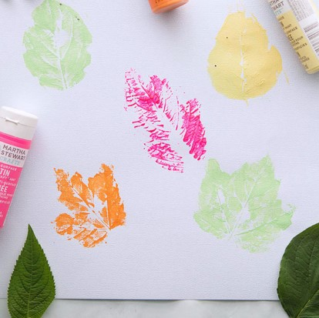
Vegetable prints
Use some different fruits and vegetables like lemons, oranges, mushrooms, broccoli or carrots. Ask an adult to help you cut the fruit in half or into chunks, then dip in to paint and press on to paper to create a print.
