Year 3 LITERACY week beginning 27.4.2020
The learning in Literacy this week links to our History topic about hunter gatherers during the Stone Age. Watch this BBC video to find out how thousands of years ago hunter gatherers searched for nuts and berries to eat and hunted for wild animals like deer.
https://www.youtube.com/watch?v=-DkXHi-udxg

Literacy Monday 27th April 2020 LI: To describe
Look at this cave painting found in a cave in France, where humans used to live over 10,000 years ago. Describe what you can see in as much detail as you can. What animals can you see?
Are there any people? What do you think the people are doing?
Use these sentence stems: I can see it looks like there are maybe there are
the people could be maybe they are going to

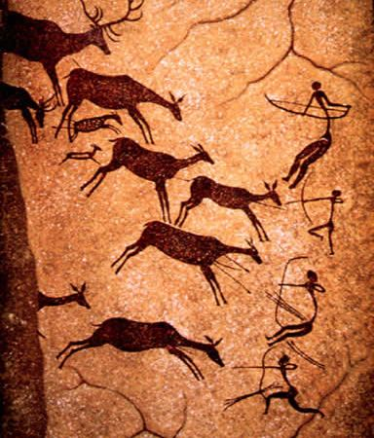
Now draw your own cave painting

Literacy Tuesday 28th April 2020 LI: To write a diary
Imagine you are a young hunter gatherer like the boy in the video and you are going out to catch your first deer.
What are you thinking and feeling as you walk in to the forest? What can you see, hear and feel in the forest? What is it like to bring a deer back to your family to cook on the fire for dinner?

Dear diary,
Today I headed in to the forest to catch my first deer.
________________________________________________________________________________________________________________________________________________________________________________________________________________________________________________________________________________________________________________________________________________________________________________________________________________________________________________________________________________________________________________________________________________________________________________________________________________________________________________________________________________________________________________________________________________________________________________________________________________________________________________________________________________________________________________________________________________________________________________________________________________________________________________________________________________________________________________________________________________________________________________________
Literacy Wednesday 29th April 2020 LI: To retrieve facts
Watch the video again. Write down as many facts as you can about life for hunter gatherers in Stone Age Britain. You could also do some further research about Stone Age hunter gatherers on this website:
https://www.bbc.co.uk/bitesize/topics/z82hsbk/articles/z34djxs

Answer these questions:
What material did Stone Age people use to make their tools?

What did people gather in the forest to eat?

What sort of animals did people hunt for?

How did they cook their food?

Why did they move to a new place when the seasons changed?

Write down any other facts that you have learned:
____________________________________________________________________________________________________________________________________________________________________________________________________________________________________________________________________________________________________________________________________________________________________________________________________________________________________________________________________________________________________________________________________________________________________________________________
____________________________________________________

Literacy Thursday 30th April 2020 LI: To write a report
Use the facts that you have learned to write a report about life for hunter gatherers in Stone Age Britain.
Include sections about: Tools, gathering, hunting, moving from place to place.
Include some labelled pictures to give extra information.
Hunter Gatherers in Stone Age Britain
This report is all about __________________________________
____________________________________________________
______________________________________________

Tools

Gathering

Hunting

Moving from place to place

Literacy Friday 1st May 2020 LI: To edit and publish a report
Proof read and edit your report from yesterday. Correct any mistakes you have made with capital letters, full stops or spellings. You could also change some parts of your report to make it clearer or more interesting, for example try coming up with your own title and your own sub-headings for sections (instead of ‘Tools’ you could have ‘Terrific Tools’).
Now re-write your report in your neatest handwriting, including all your improvements.
________________________________________________________________________________________________________________________________________________________________________________________________________________

