Talking Point
Dear children and parents,
Here is a little talking point to discuss as a family when you get a spare moment, maybe at lunch time or tea time, or any other time when you like to chat.
Have you watched any super hero films recently or read any comics? What is your favourite super hero super power? Flying? Super strength? Becoming invisible?
This week’s talking point is:
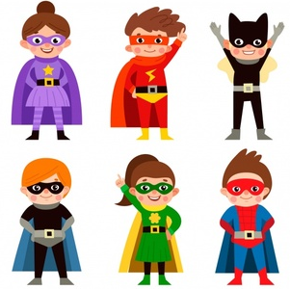
Flying is the best super power.
Do you agree or disagree? Explain why
You can use these sentence stems to help you discuss:
I agree because
I disagree because
I would like to challenge this because
Building on what __________ has said, I would like to add

