Scientists often collect different types of rocks and look at them very closely. When you collect samples, it’s important to ask questions so you can compare how similar or different the rocks are.
For Example:
Is it smooth or rough? Is the texture/colour the same throughout?
How does the inside differ from the outside?
Are there any crystals or grains? If so, what size and colours are they?
Is the it solid or are there air holes throughout?

Chocolate Experiment
What you will need:
Different types of chocolate (milk, white, plain, chocolate with honeycombs, pieces of sweet crystals, raisins and biscuits, and chocolate that is aerated/full of holes)
- Look at your chocolate samples and discuss how they look, use the questions above to help you. You might want to write your descriptions and label the samples.
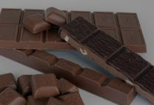

- If you have a garden, you could collect real rock samples. You can apply the same questions and create detailed descriptions of real rocks and then sort your rocks into different groups.
