Key Vocabulary
Rock | A hard, solid material that is made of minerals and is found in nature.
Soil | The top layer of the ground, in which plants grow.
Mineral | A solid, natural material that does not come from a living thing
Igneous  Rock | Rock formed by the cooling and hardening of hot magma or lava. Formed by volcanoes (e.g. basalt, granite).
Sedimentary Rock | These are formed when igneous rocks are eroded under the sea. Formed over a long period of time (e.g. shale, limestone, sandstone).
Metamorphic Rock | These are formed when igneous and sedimentary rocks are compressed (e.g. marble, slate).
The Rock Cycle | The series of changes that a rock undergoes over time as it shifts between different types.
Fossil | The remains of a plant or animal which has turned into stone over a long period of time. Mostly found in sedimentary rock
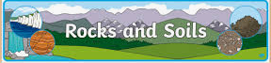

How are Fossils formed?
A fossil is the preserved remains of a dead organism. The process by which a fossil is formed is called fossilisation. After an animal dies, the soft parts of its body decompose leaving the hard parts, like the skeleton, behind. This becomes buried by small particles of rock called sediment.
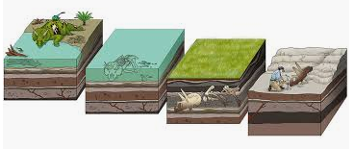

What is Soil? Why do we need it?
Soil is made up of very thin particles of rock that have mixed with air, water and particles from dead plant and animal matter. There are three main groups of soil. These are sand, silt and clay.
Many animals, plants and fungi live in soil. Soil is important because nutrients in soil help plants to grow.

The Different Types of Rock
There are three main types of rocks: Sedimentary, Igneous and Metamorphic. Each of these rocks are formed by physical changes such as melting, cooling, eroding which are all part of the rock cycle.



