Hi Year 3,
Hope you are all well!
If you have Internet access at home then please go to the BBC Bitesize website for key stage 2 (Rocks and Soil).
Watch the videos about rocks and complete the activities.
Have Fun!
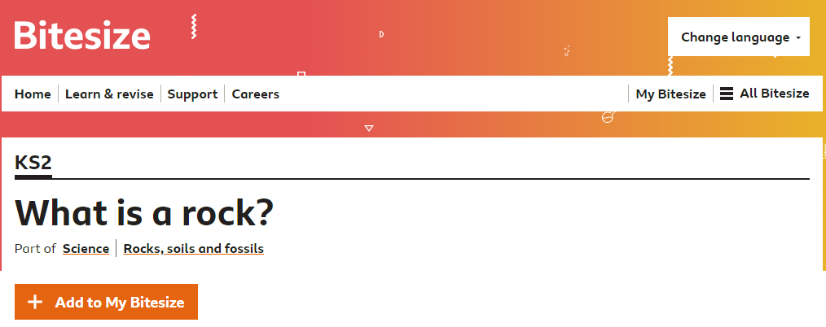
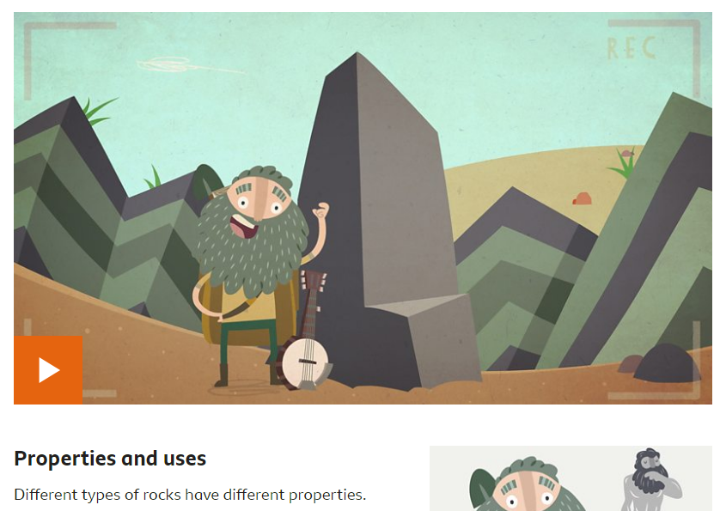

Log onto Science Bug.
Watch the video about Types of Rock, read your Knowledge Organiser as well as the information sheets about different types of rock.
You can then complete your worksheet.
